**UCSD Project Overview**

**Team VISION**

Derek Lam: [msonetwothree@gmail.com](mailto:msonetwothree@gmail.com) ← use this one

Kevin Tain: kevintain@hotmail.com

Richard Chum: Chum.richard@gmail.com

• Primary Goal = vision system to detect presence of a dog.

• Secondary goal = detect amount of waste.

**Video Demonstration (2/4/18):**

<https://drive.google.com/file/d/1EfNvftPbHNxwcg2GKMeGLNqBuKlJ4XOF/view?usp=sharing>

Project Specifications: <https://drive.google.com/open?id=1kWwSFMF2JqANHRAvvXSDTujcv9SIOJbxPY8jy82HxC4>

Gantt Chart

<https://drive.google.com/open?id=1de4An-UkEW2161-FHVP-tRgSbkG20ViibnS2RAD1piU>

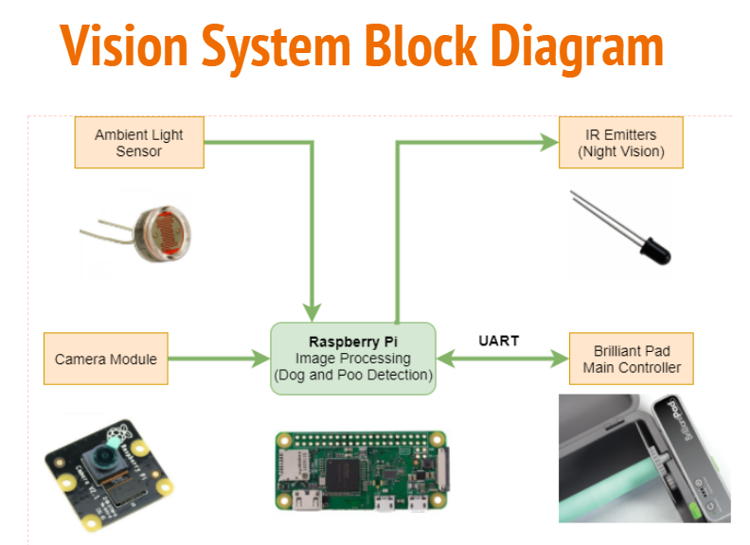

**Team CONTROL**

Kelton Chang

• Primary goal = user can send signal to machine via web/wireless to advance pad

• Secondary goal = system reads states from TEAM VISION to send signal to advance pad

• Deleted goal = connect to home network ← *focus on user interface instead*

**Brilliant Pad Team**

Alan Cook

Kris Grube

Bruno

**FedEx tracking numbers:**

Kelton - Machine [789395700733](https://www.fedex.com/fedextrack/?tracknumbers=789395700733) Rolls: [789395711009](https://www.fedex.com/fedextrack/?tracknumbers=789395711009)

Lam - Machine [789395700560](https://www.fedex.com/fedextrack/?tracknumbers=789395700560) Rolls: [789395710881](https://www.fedex.com/fedextrack/?tracknumbers=789395710881)

**EMAIL WITH TEAM VISION**

My teammate, Richard, had emailed you regarding the vision system portion of the Brilliant Pad as our project for CSE 145. We just wanted to follow up and ask if there were any updates on how we should streamline the process of communication between our team and your company. We have our first assignment this Wednesday: [**http://kastner.ucsd.edu/ryan/cse145/project-overview/**](http://kastner.ucsd.edu/ryan/cse145/project-overview/)and we had some questions:

**1. Has your team already come up with any technical specifications for the vision system? For example, are there any specific cameras in mind? We were thinking of purchasing a Raspberry Pi Camera for a first prototype.**

*No, we don’t have particular camera systems in mind. Rasperry Pi is an acceptable camera.* ***KRIS*** *will also suggest some other sensors you may want to consider.*

**2. Should the vision system be operable in the dark? If so - we were also thinking of including some sort of "night vision" through IR emitters.**

*Kris and I were talking about this. Yes, ideally, the camera system will work in the dark, but we defer to you.*

**Proposal from Kelton:**

• use Raspberry Pi camera system

• work in daylight and darkness

Location

Conduit between RPi and Machine:

• dog presence (yes/no)

• waste presence (yes/no)

• waste quantity (amount)

• user threshold of waste or weight (no weight for not, percentage of clean/dirty)

• status of roller (what does this mean?)

• status of roller door (what does this mean?)

Architecture:

• RPi connects to home server, which in turn connects to web server

• Web server has interface to operate BP via browser or mobile device

Milestones:

• User control of BP via browser or mobile device

• Easily connect machine to home network

**BRILLIANT PAD QUESTIONS TO TEAM VISION AND TEAM CONTROL:**

1. How will work be coordinated between VISION and CONTROL teams?

* Will need to establish form of communication between the two teams.
* Could possibly merge into one team for CSE 145, but with split duties

2. Where will processing take place to determine DOG PRESENCE, WASTE PRESENCE and WASTE AMOUNT? Home server? Elsewhere?

* For prototyping, TEAM VISION is planning to do all processing on home server (Raspberry Pi)

3. Will TEAM VISION be responsible for DOG PRESENCE, WASTE PRESENCE and WASTE AMOUNT variables?

* Yes

4. How will TEAM CONTROL get data from TEAM VISION for DOG PRESENCE, WASTE PRESENCE and WASTE AMOUNT variables?

* TEAM CONTROL will be developing on a Raspberry Pi which I believe the TEAM VISION will also be doing. We can just pass values from each other’s methods for control and detection.
* Should vision system and control system be developed on the same Pi? Developed separately and merge later? Or kept on separate Pi’s?
* If kept separate: Processed data from one Pi can be saved to an online database, and can be retrieved from second Pi, OR data sent directly through wired connection over some protocol.

5. Consider LIQUID waste and SOLID waste. They look and image differently. Ideally system can distinguish between them. Does team want to create SOLID WASTE and LIQUID WASTE variables?

* This could most likely be done. Admittedly, TEAM VISION currently does not have that much experience in OpenCV/ other image processing platforms, but lots of research will need to be done to figure out a method for distinguishing solid waste and liquid waste.
* However, how would differentiating between solid waste and liquid waste help the user? Would solid waste be considered “more” waste than liquid waste? Or something else?

6. We seem to create the simplest control link between student system and BP, i.e., we will probably create a hook that allows student system to send an ADVANCE PAD X-NUMBER OF MARKS command, i.e., the system will advance the pad one mark. You will be able to tell machine to advance 1 mark, 2 marks, etc. 5 marks is a full sheet. *Scroll to bottom of document and look at links regarding paper sensor. The videos will explain what we mean.*

7. Ideally user will be able to implement the following commands or actions:

* Advance 1 mark
* Advance 5 marks
* Advance until clean
* Advance until clean when x-threshold of waste is reached
* Advance until x-threshold of waste is reached
* Look in and see camera
* Set waste threshold

8. Rather than explore eas(ier) setup of connecting home server to network, we’d rather see greater exploration of user controls and commands, i.e., user can set waste/dirty threshold, look in an see camera from afar, log events, i.e., when did dog arrive, how much was left behind, etc. Remote control interface and data log is more interesting to us than connecting home server to network.

**Based on this, please suggest how you will define responsibilities between TEAM VISION and TEAM CONTROL, and restate your objectives consistent with this briefing.**

All best, Alan

**PREVIOUS TEAM QUESTIONS - ALAN’S ANSWER IN ITALICS**

**1. Why aren't you guys using some sort of scale or another sensor to measure weight to know if the dog is on or off the pad?**

*All of the electronics are in the control module. This allows us to keep the rest of the machine “dumb” and simplify our manufacturing.*

**2. What sensors were currently in use again (infrared or something else)?**

*There is an IR sensor for animal detection. Fast forward to 1:45 in this video:*

[*https://www.dropbox.com/s/6jydntuikxphd31/2.%20BrilliantPad%20Setup%20Video.mp4?dl=0*](https://www.dropbox.com/s/6jydntuikxphd31/2.%20BrilliantPad%20Setup%20Video.mp4?dl=0)

*There is also an IR sensor for paper detection, which is used to read marks under the paper, flag tracking errors and out-of-paper conditions:*

[*https://www.dropbox.com/s/0ugzbp6x0gtjoao/1.%20Paper%20Sensor%20Reads%20Index%20Marks.mp4?dl=0*](https://www.dropbox.com/s/0ugzbp6x0gtjoao/1.%20Paper%20Sensor%20Reads%20Index%20Marks.mp4?dl=0)

[*https://www.dropbox.com/s/vhbtjl2xtki3phf/2.%20Tracking%20Error%20A%20SIGN.mov?dl=0*](https://www.dropbox.com/s/vhbtjl2xtki3phf/2.%20Tracking%20Error%20A%20SIGN.mov?dl=0)

[*https://www.dropbox.com/s/e7wn24b7ulax79q/3.%20End%20of%20Roll%20Detection.mov?dl=0*](https://www.dropbox.com/s/e7wn24b7ulax79q/3.%20End%20of%20Roll%20Detection.mov?dl=0)

**3. Are there specific requirements that we are to fulfill (i.e. must use a specific microcontroller or programming the actual device) or is it more open ended where we would develop a mockup from scratch and could change the design of the project?**

*This is worthy of a conversation. If you do a vision system to detect animal and/or waste then we can create it independently of our current hardware. If you want to connect to current controller we could provide access to UART and define a protocol for chatting with Board. I suggest we approach this independently and “merge” with our controller in the future.*

*Requirements:*

*• detect dog -- is dog present, yes or no?*

*• detect waste -- is pad clean or dirty?*

*• determine how dirty pad is -- if pad is dirty, is it 10%, 20% 30%, etc. covered by waste?*

*Stretch goals or optional requirements to add wifi controls -- SEE REQUIREMENTS ABOVE*

*1. let user see platform*

*2. let user advance pad -- we will provide a hook to send a command to advance pad*

*3. show user status of LED’s on control panel -- DELETED*

*4. shows user log of dog visits (to be defined) --*

**4. Is there a formal write up of the three projects that we can choose from?**

*1. new IR system to define dog*

*2. vision based system to detect dog, determine if waste is on pad*

*3. WIFI control of machine, see status of LED’s, see what the camera sees for vision system*

**We have greatest interest in #2 and #2**

I think you meant #2 and #3 -- Alan

**5. If we were to choose to work with BrilliantPad, would there be a "mentor" that we would talk to for help and clarifications?**

*Yes, you will have access to our senior leadership team. CEO, engineering lead, marketing leader and supply chain lead fully support this project and will be available for regular interactions with students in person and via Skype.*

Team Member Biographies:

President - https://www.linkedin.com/in/alanjcook/

Engineering leader - https://www.linkedin.com/in/krisgrube/

Marketing leader - https://www.linkedin.com/in/david-preuss-23a39016/

Supply chain leader - https://www.linkedin.com/in/kevin-augustyniak-73a102/

Please let us know if you have questions for anyone on team, i.e., Alan, Kris, Bruno or Dave.

*Additional helpful info:*

*We are not seeking a commercial grade product. Our goal is to receive a proof of concept demonstration of some of the features listed here so that we can refine product requirements and evaluate trade offs between major system components.*

*Work will lead to commercialization. Students WILL see the results of their effort affected in final product to be available in retail and online web stores!*

*Team has extensive experience commercializing consumer and industrial products and has advanced degrees in engineering and business from Penn, Harvard and MIT. We previously developed the ScoopFree self-cleaning litter box and FroliCat family of electronic pet toys.*

For more information contact:

Alan Cook

alan@brilliantpet.com

312-404-2526

**AJC NOTE: See Kinja for deal on Raspberry Pi:**

